State Electoral Boundaries

<http://www.elections.nsw.gov.au/about_elections/electoral_boundaries/electoral_maps>

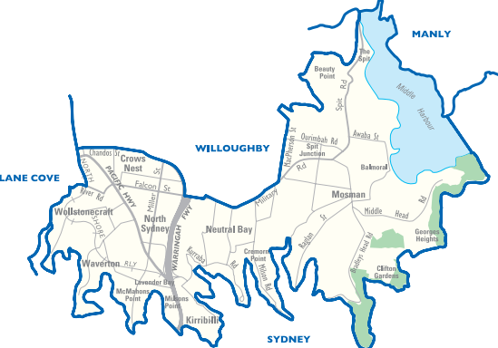 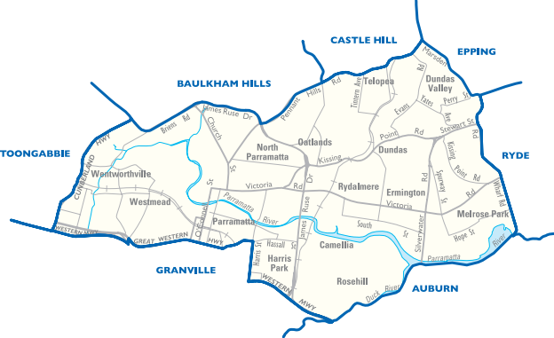

Parramatta

North Shore

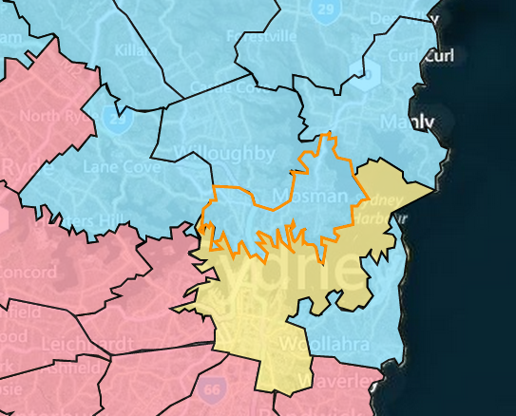 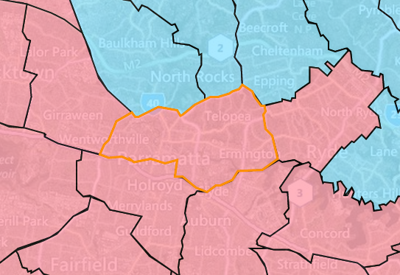

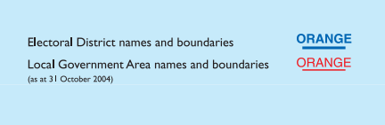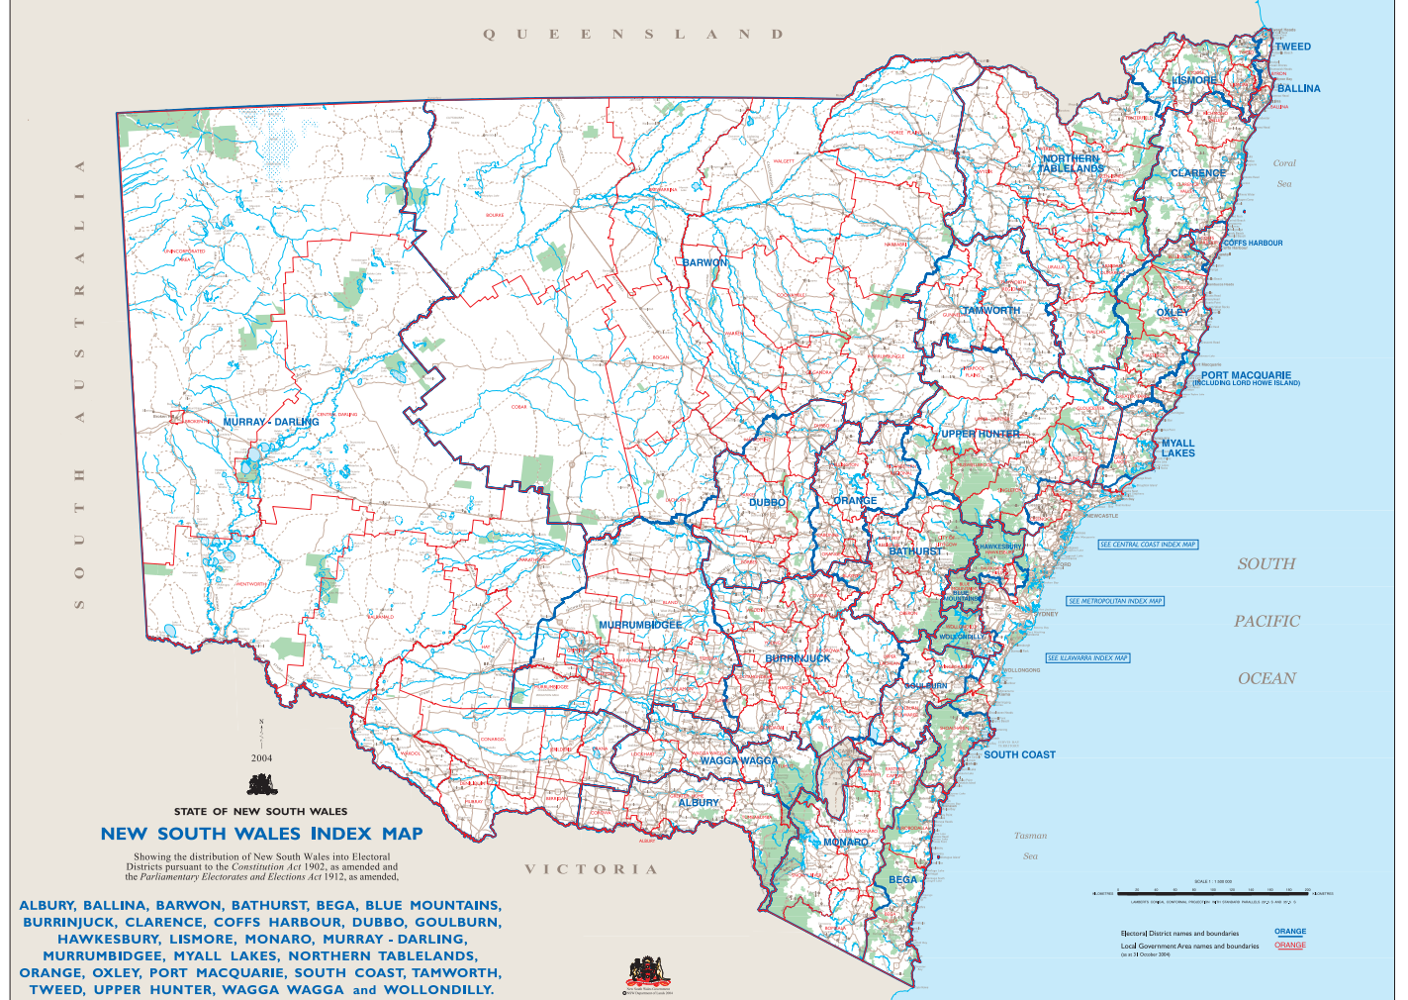

State Electoral Boundaries: 2011 ([http://atlas.nsw.gov.au/public/nsw/home/map/elections.html#](http://atlas.nsw.gov.au/public/nsw/home/map/elections.html))

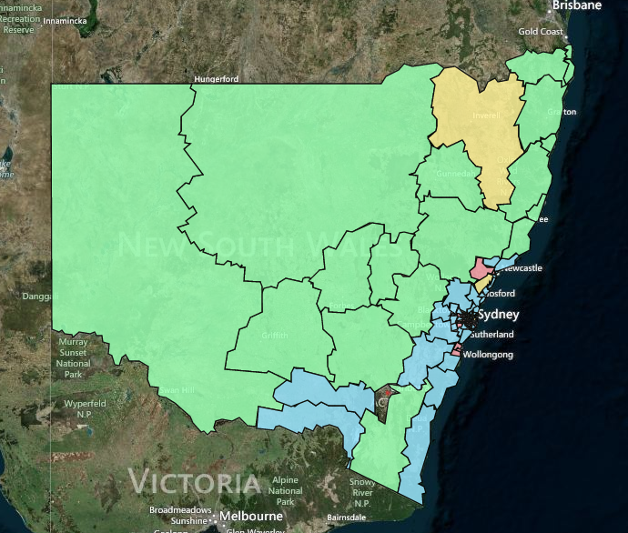

State Electoral Boundaries: 2007

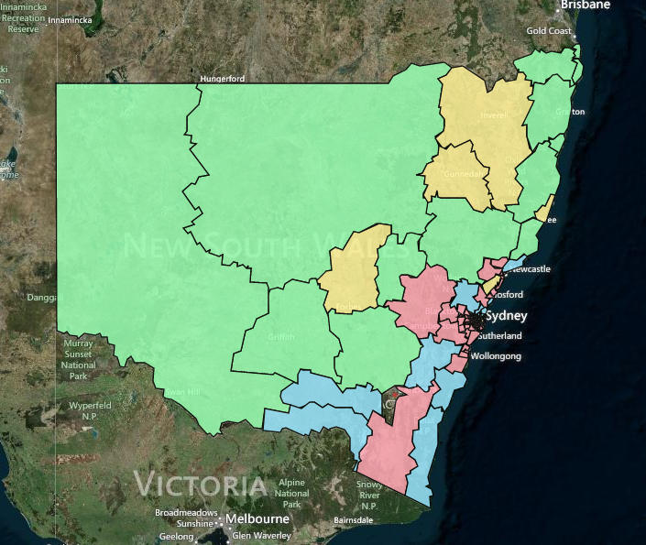

State Electoral Boundaries: 2003

